**THAKUR POLYTECHNIC**

**Computer Engineering Department**



**SYCO-A SEMESTER - 4**

**[2023-2024] Group – 26**

SUB: **DATA COMMUNICATION AND**

**COMPUTER NETWORK (22414)**

**1.Shinde Urvi Arun-151**

**2.Shrimali Lakshakumar Mukesh-152**

**3.Suryavanshi Pranav Hemchandra-153**

**4.Uvarna Sachin Sandesh-154**

**5.Chaugule Rushikesh Manohar-155**

**6.Tejaswini Bharat Bhujbal-156**

Guided by **Mrs. Smita Dandge**



**MAHARASHTRA STATE BOARD OF**

**TECHNICAL EDUCATION**

This is to certify the following group of students roll no. **151-156** of **4th** semester of Diploma in **COMPUTER ENGINEERING** of institute, **THAKUR POLYTECHNIC** (Code: 0522) has completed the **Micro Project** satisfactorily in subject - DCC (22414) for the academic year 2023 –2024 as prescribed in the curriculum.

**Place: Mumbai Enrollment No.: ___________ Date: _____________ Seat No.: _________________**

# Subject teacher Head of Department Principal



**Seal of**

**Institution**

**ACKNOWLEDGEMENT**

Performing our assignment, we had to take the help and guideline of some respected persons, who deserve our greatest gratitude. The completion of this assignment gives us much Pleasure. We would like to show our gratitude to **Mrs. Smita Dandge**, Course Instructor, **Thakur Polytechnic** for giving us a good guideline for assignment throughout numerous consultations. We would also like to expand our deepest gratitude to all those who have directly and indirectly guided us in writing this assignment.

In addition, a thank you to Lecturer **Mrs. Smita Dandge**, who introduced us to the Methodology of work, and whose passion for the “underlying structures” had lasting effect.

Many people, especially our classmates and team members, have made valuable comment suggestions on this proposal which gave us inspiration to improve our assignment. We thank all the people for their help directly and indirectly to complete our assignment.

# PROPOSAL

**PROPOSAL**

## Title : Study on Application layer protocol (TELNET)

1. **BRIEF INTRODUCTION:**

Data communications refers to the transmission of this digital data between two or more computers and a computer network or data network is a telecommunications network that allows computers to exchange data. The physical connection between networked computing devices is established using either cable media or wireless media. The best-known computer network is the Internet.

1. **AIM OF THE MICRO PROJECT:**

* Understand its purpose and role in remote terminal access.
* Learn its fundamentals and protocol specifications.
* Explore security vulnerabilities and considerations.
* Compare with modern alternatives like SSH.
* Gain practical implementation experience.
* Analyze case studies for insights.
* Consider future developments and trends.

**3. COURSE OUTCOMES:**

a. Analyze the functioning of data communication and computer network.

e. Configure different TCP/IP services

1. **ACTION PLAN:**



|  |  |  |  |  |
| --- | --- | --- | --- | --- |
| **Sr No.** | **Details of activity** | **Planned start date** | **Planned finish date** | **Name of**  **Responsible Team**  **Members** |
| 1. | Information Research |  |  |  |
| 2. | Group Discussion |  |  |  |
| 3. | Taking Reference |  |  |  |
| 4. | Executions |  |  |  |
| 5. | Compilation of reports |  |  |  |
| 6. | Presentation and  Report submission |  |  |  |

1. **RESOURCES REQUIRED:**

|  |  |  |  |  |
| --- | --- | --- | --- | --- |
| **Sr No.** | **Name of resources** | **Specifications** | **Quantity** | **Remarks** |
| 1. | Google Chrome | Search Engine | 1 | Available |
| 2. | Microsoft Word | Ms. Office 2019 | 1 | Available |
| 3. | Computer System | Intel i3 6006U  8GB RAM | 1 | Available |



|  |  |
| --- | --- |
| **Roll Numbers of the Team Members** | **Names of the Team Members** |
| 151 | Shinde Urvi Arun |
| 152 | Shrimali Lakshakumar Mukesh |
| 153 | Suryavanshi Pranav Hemchandra |
| 154 | Uvarna Sachin Sandesh |
| 155 | Chaugule Rushikesh Manoha |
| 156 | Tejaswini Bharat Bhujbal |

**Mrs. Smita Dandge**

**(Subject Teacher)**

# REPORT

**Report**

## Title : Study on Application layer protocol (TELNET)

**1. RATIONALE:**

A data communication and computer networks has been growing with rapid technological progress. Computer communication through networking becomes essential part of our life. By considering importance of networking in day today life. it is essential for students to know the basic concept of networks like network classification. network topologies. network devices. This course deal with the important concepts and techniques related to data communication and enable students to have an insight in to technology involved to make the network communication possible.

1. **AIMS/BENEFITS OF THE MICRO PROJECT:**

* Understand its purpose and role in remote terminal access.
* Learn its fundamentals and protocol specifications.
* Explore security vulnerabilities and considerations.
* Compare with modern alternatives like SSH.
* Gain practical implementation experience.
* Analyze case studies for insights.
* Consider future developments and trends.

1. **COURSE OUTCOMES ACHIEVED:**

a. Analyze the functioning of data communication and computer network.

e. Configure different TCP/IP services

1. **LITERATURE REVIEW:**

**History:**

The TELNET application layer protocol, born out of the nascent stages of computer networking in the late 1960s and early 1970s, played a pivotal role in facilitating remote terminal access during the early days of the internet.

As one of the first protocols developed within the ARPANET project, TELNET quickly gained traction and was standardized by the Internet Engineering Task Force (IETF) in the 1980s, with RFC 854 serving as a foundational document.

Throughout the 1980s and 1990s, TELNET saw widespread adoption, allowing users to remotely log in to computers and servers and interact with command-line interfaces. However, its popularity waned in the late 1990s and early 2000s due to significant security vulnerabilities, primarily stemming from its transmission of data in plaintext.

This flaw made TELNET susceptible to eavesdropping and interception, leading to the development and adoption of more secure alternatives like SSH (Secure Shell). Despite its decline, TELNET still maintains a presence in certain niche environments where security is not a primary concern or where legacy systems necessitate its usage for compatibility reasons.

Thus, the history of TELNET encapsulates the early evolution of computer networking and underscores the critical importance of security considerations in protocol design and implementation.

**5. OUTPUT:**

**1. Introduction:**

TELNET, or TErminaL NETwork, is an early application layer protocol developed for remote access to computing resources over a network. Standardized in 1983, it allowed users to interact with command-line interfaces on distant hosts. While once widely used, its plaintext transmission of data led to security concerns, causing a decline in favor of more secure alternatives like SSH. Nonetheless, TELNET retains relevance in legacy environments where compatibility is paramount.

1. **Types Of Application layer Protocol:**

Web Protocols: These include HTTP (Hypertext Transfer Protocol) for web browsing, HTTPS (HTTP Secure) for secure web communication, and FTP (File Transfer Protocol) for transferring files over the internet.

Email Protocols: Examples include SMTP (Simple Mail Transfer Protocol) for sending emails, POP3 (Post Office Protocol version 3) and IMAP (Internet Message Access Protocol) for retrieving emails from servers.

Remote Access Protocols: TELNET (TErminaL NETwork) and SSH (Secure Shell) are examples used for remote access to network devices or servers.

Domain Name System (DNS): DNS resolves domain names to IP addresses, facilitating internet communication by translating human-readable domain names into machine-readable IP addresses.

Streaming Protocols: Protocols like RTSP (Real-Time Streaming Protocol) and RTP (Real-Time Transport Protocol) are used for streaming multimedia content over networks.

Voice over IP (VoIP) Protocols: SIP (Session Initiation Protocol) and H.323 are examples of protocols used for voice and video communication over the internet.

File Sharing Protocols: Protocols such as SMB (Server Message Block) and NFS (Network File System) enable file sharing and access to shared files and resources over a network.

These are just a few examples, and there are many other application layer protocols serving various communication and networking needs.

**3. Working:**

Telnet is a protocol that was widely used in the past for accessing remote computer systems over the internet. It allows a user to log in to a remote system and access its command line interface as if they were sitting at the remote system’s keyboard. Telnet was one of the first widely used remote access protocols, and it was particularly popular in the days of mainframe computers and timesharing systems.

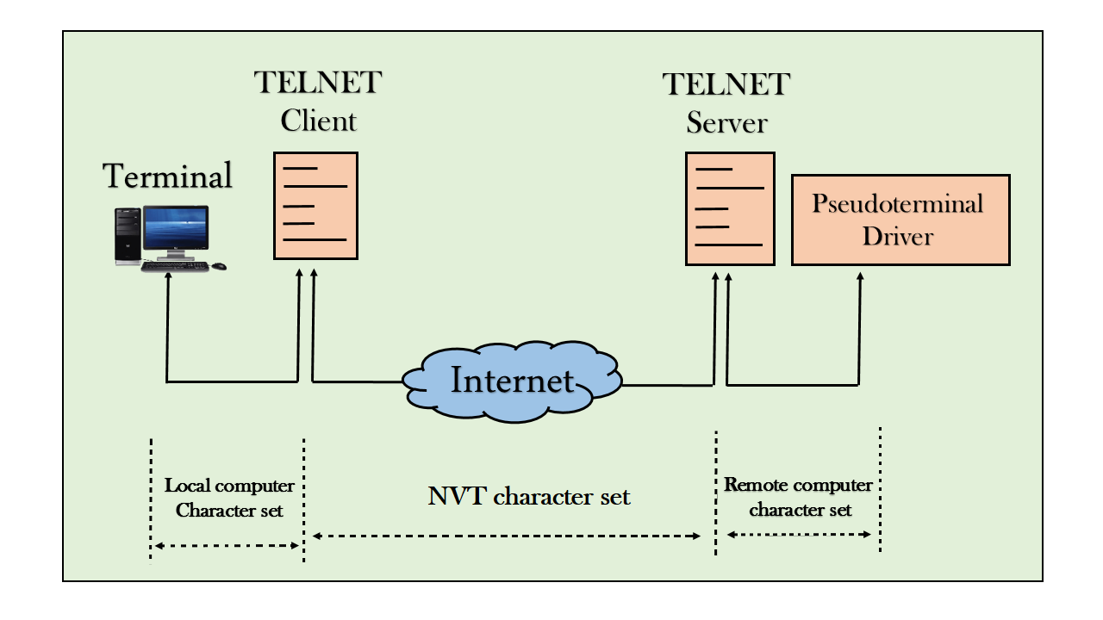

Telnet operates on the Application Layer of the OSI model and uses a client-server architecture. The client program, which is typically run on a user’s computer, establishes a connection to a Telnet server, which is running on the remote system. The user can then send commands to the server and receive responses.

While Telnet was widely used in the past, it has largely been replaced by more secure protocols such as SSH (Secure Shell). Telnet is not considered a secure protocol, as it sends all data, including passwords, in plain text. This makes it vulnerable to eavesdropping and interception. In addition, Telnet does not provide any encryption for data transmission, which makes it vulnerable to man-in-the-middle attacks.

Today, Telnet is primarily used for debugging and testing network services, and it is not typically used for accessing remote systems for daily use. Instead, most users access remote systems using protocols such as SSH, which provide stronger security and encryption.



**4. Advantages and Disadvantages:**

Advantages:

1. Simplicity: TELNET is straightforward to implement and use, making it accessible for remote terminal access and management tasks.
2. Compatibility: It's widely supported across different operating systems and network devices, ensuring interoperability in heterogeneous environments.
3. Resource Efficiency: TELNET sessions typically consume fewer resources compared to graphical remote access methods, making it suitable for low-bandwidth connections or systems with limited processing power.
4. Legacy Support: In environments where older systems or devices rely on TELNET for remote access, its continued support ensures compatibility and operational continuity.
5. Ease of Integration: TELNET can be easily integrated into existing network infrastructure and management tools without requiring significant modifications or investments.

Disadvantages:

1. Plaintext Transmission: TELNET transmits data, including usernames, passwords, and command inputs, in plaintext format. This makes it highly vulnerable to interception and eavesdropping. Attackers can easily capture sensitive information by sniffing network traffic.
2. Authentication Vulnerabilities: Since TELNET does not encrypt authentication credentials, such as usernames and passwords, they are sent across the network in an easily readable format. This exposes users to the risk of credential theft and unauthorized access to systems and accounts.
3. No Data Integrity Protection: TELNET lacks mechanisms to ensure the integrity of transmitted data. As a result, attackers can modify or inject malicious commands into the data stream, leading to potential system compromise or data manipulation.
4. No User Privacy: Due to the absence of encryption, TELNET users have no privacy protection. Any data transmitted, including sensitive information or communication, can be monitored and viewed by unauthorized parties.
5. Security Risks Across Networks: TELNET's security vulnerabilities are not limited to local networks. Even over secure networks, such as private corporate networks or VPNs, TELNET sessions remain susceptible to interception and exploitation.

1. **Conclusion:**

In conclusion, TELNET's historical role in remote terminal access is overshadowed by its critical security flaws. Transmitting data in plaintext exposes sensitive information to interception, rendering it unsuitable for modern secure environments. Organizations have shifted to encrypted alternatives like SSH, relegating TELNET to legacy systems where security is less critical.

1. **ACTUAL METHODOLOGY USED:**

* Getting the overview of the project and understanding the concept thoroughly.
* Collecting information about application layer protocol (TELNET)
* Making of the proposal.
* Making of the Report.

1. **ACTUAL RESOURCES USED:**

|  |  |  |  |  |
| --- | --- | --- | --- | --- |
| **Sr No.** | **Name of resources** | **Specifications** | **Quantity** | **Remarks** |
| 1. | Google Chrome | Search Engine | 1 | Available |
| 2. | Microsoft Word | Ms. Office 2019 | 1 | Available |
| 3. | Computer System | Intel i3 6006U 8GB RAM | 1 | Available |

1. **SKILLS DEVELOPED/LEARNING OUT OF THE MICRO PROJECT:**

* What is TELNET and how it works.
* We learned technical skills for networking fundamental, protocol analysis and troubleshooting.
* Features and Characteristics of Application layer protocol

**9. APPLICATIONS OF THE MICRO PROJECT:**

* Legacy Systems: Used for accessing and managing older systems lacking support for modern protocols.
* Internal Networks: In controlled environments, it's used for remote administration of devices like routers and switches.
* Education: TELNET is used in educational settings for teaching networking concepts and protocol analysis.
* Debugging and Testing: Helpful for debugging network applications and testing connectivity.
* Embedded Systems: Some IoT devices may use TELNET for remote administration due to compatibility or resource constraints.

**Mrs. Smita Dandge**

**(Subject Teacher)**